INVENTION DISCLOSURE FORM
1. Field of the Invention
a. Nature of the invention
[ ] Product / Device
[✓] Process / Method
[ ] Composition
[✓] System
[✓] Software
[ ] Design
[✓] Hybrid — Software-based cybersecurity system and method
b. Technical area
The invention relates to cybersecurity, machine learning, web application security, and phishing detection. It describes a software-based system that combines machine-learning analysis of URL features with rule-based analysis of webpage HTML and identity-related indicators to generate an explainable phishing-risk assessment.

2. Title of the Invention
FakeGuard: A Hybrid Machine-Learning and Rule-Based System for Explainable Phishing Risk Assessment of URLs and Webpages

3. Background and Objectives
a. Problem addressed
Phishing websites imitate legitimate websites to deceive users into providing passwords, account information, and other sensitive data. Detection methods that rely primarily on URL characteristics may not identify suspicious features within a webpage. Similarly, some legitimate websites may contain characteristics that trigger false warnings.
There is a need for an accessible system that evaluates multiple URL and webpage indicators, combines their results, and explains the reasons for its risk assessment rather than displaying only a classification or an unexplained score.
b. Objectives of the invention
- To develop a software-based system that assesses phishing-related risks associated with a submitted URL and its accessible webpage.
- To combine machine-learning predictions with rule-based analysis of webpage structure and identity-related indicators.
- To identify suspicious characteristics such as password fields, external form destinations, embedded frames, external links, and possible brand-domain mismatches.
- To generate an overall heuristic risk score, a risk category, and understandable explanations for the assessment.
- To implement safeguards during webpage retrieval, including redirect validation, network-address checks, timeouts, and response-size restrictions.
- To provide a user-friendly web interface for submitting URLs and examining the assessment.
- To support human review of suspicious websites without treating individual warning signs as conclusive proof of phishing.
c. Solution
The proposed system, FakeGuard, is a Python-based web application implemented using Flask. It accepts a URL, retrieves accessible webpage HTML using guarded fetching logic, and extracts selected URL and webpage features. A Random Forest machine-learning model evaluates its selected input features, while a separate risk engine evaluates webpage characteristics and identity-related indicators.
The risk engine combines these signals and applies configured adjustments under specified conditions. FakeGuard then displays an overall heuristic risk score, a risk category, reasons for the assessment, and supporting technical information.
The system is intended to assist in phishing-risk assessment. Its score is not a calibrated probability, and the system does not guarantee that every website will be classified correctly.

4. Description of the Invention
a. Brief description and working, step by step
Step 1: URL submission
The user enters a website address through the FakeGuard web interface.
Step 2: URL validation and webpage retrieval
The Flask application validates the submitted address and attempts to retrieve the accessible webpage. The fetching component incorporates redirect validation, checks against local and private network destinations, timeouts, redirect limits, and response-size limits.
Step 3: Feature extraction
The feature engine extracts selected characteristics from the submitted URL and retrieved webpage HTML. These may include URL-related attributes, password fields, external links, embedded frames, form destinations, and identity-related terms.
Step 4: Machine-learning analysis
A Random Forest model processes its selected input features and generates a model risk score. The model runtime is stored in the file fakeguard_model_runtime.joblib.
Step 5: Rule-based webpage analysis
The risk engine evaluates webpage characteristics and identity-related warning signals. For example, it may identify a password field or a form that sends information to a different domain.
Step 6: Risk fusion
The risk engine combines the machine-learning score with HTML-related risk and identity-related risk. It also applies configured adjustments for selected combinations of indicators and certain discrepancies between model output and webpage characteristics.
Step 7: Risk categorisation
The final score is mapped to the application's configured categories:
- Low risk: below 45%.
- Medium risk: 45% to below 75%.
- High risk: 75% and above.
Step 8: Result presentation
The application displays the final risk score, risk category, reasons for the assessment, and technical indicators such as HTTPS usage, password fields, external links, form destinations, and embedded frames.
Step 9: Report review
The user can review and print or save the displayed report using the available interface functionality.
The webpage analysis examines retrieved HTML without executing the webpage's JavaScript. Consequently, some dynamically generated content and behaviours may not be detected.

b. Major components and their interconnection
- Web interface: Accepts a submitted URL and displays the results.
- Flask application (app.py): Coordinates requests, invokes the analysis components, and provides the web interface and analysis API.
- Feature engine (feature_engine.py): Performs guarded webpage retrieval and extracts URL and HTML features.
- Machine-learning model: Evaluates selected features and generates a model risk score.
- Risk engine (risk_engine.py): Combines the model score with rule-based and identity-related risk signals and determines the final assessment.
- Brand-domain checking logic: Checks supported brand references against configured official-domain information and can trigger a manual-review warning.
- Model runtime (fakeguard_model_runtime.joblib): Stores the trained model runtime used by the application.
- Results interface: Displays the risk score, category, reasons, and technical details.
The components are interconnected through the following processing flow:
URL Input → Flask Application → Guarded Webpage Retrieval → Feature Extraction → Machine-Learning and Rule-Based Analysis → Risk Fusion → Risk Categorisation → Explained Results

5. Novelty Status
a. Is the invention an entirely new development, or an improvement over an existing product or process?
[ ] Entirely new development established to be novel.
[✓] Improvement or implementation of an existing process using a particular combination of techniques.
FakeGuard implements a combination of established machine-learning, webpage-analysis, and rule-based techniques. Its specific implementation may contain distinguishing features, but its novelty and patentability have not yet been established through a formal patentability assessment.
b. If an improvement, identify the existing product or process and describe the modifications made.
Existing phishing-detection approaches include URL-based classifiers, blacklist-based detection, webpage-content analysis, and machine-learning systems.
FakeGuard incorporates the following implementation features:
- Combination of a Random Forest model score with webpage and identity-related warning signals.
- Conditional risk adjustments when certain webpage characteristics conflict with the model's initial assessment.
- Brand-domain mismatch checks that may impose a minimum score for manual review.
- Guarded webpage retrieval with redirect validation, network-address checks, timeouts, and response-size limits.
- An explainable results interface that displays warning reasons alongside the final risk score.
- Retention of the submitted URL as an input to analysis even when redirects lead to a different destination.
These features are proposed for further evaluation against existing technologies. Their novelty and inventive step require a formal review.
c. If a new use of an existing product or process, state the conventional use and the new use proposed.
The project applies established machine-learning and rule-based analysis techniques in a software workflow that evaluates submitted URLs and accessible webpage HTML to produce an explainable phishing-risk assessment. No separate new use of a physical product is claimed.

6. Novel and Distinguishing Features
The following candidate distinguishing features are proposed for assessment:
- Combined risk assessment: Integration of machine-learning results with HTML-related and identity-related risk indicators.
- Conditional risk adjustment: Modification of the final assessment when configured combinations of signals indicate that the initial model output may not adequately represent webpage risk.
- Brand-domain mismatch handling: Use of supported brand-domain checks to trigger warnings and a minimum manual-review score.
- Guarded webpage analysis: Retrieval and analysis of accessible webpage HTML using specific network-fetching safeguards.
- Explainable risk output: Presentation of the final score with the warning indicators that contributed to the assessment.
- Preservation of submitted URL context: Use of the originally submitted URL as an input even when a redirect leads to another destination.
These features describe aspects of the implemented system. They are not a declaration that the features are legally novel or patentable.

7. Detailed Description of the Specific Novel and Unusual Features
7.1. Combined risk-scoring mechanism
FakeGuard combines a machine-learning risk score, HTML-related risk, and identity-related risk. In the current implementation, the base calculation uses the following form:
Final base risk = min(1, (0.55 × ML risk) + (0.25 × HTML risk) + (0.20 × identity risk))
The system can apply configured additional adjustments to the base calculation when specified conditions are met. The resulting risk score is bounded by the application's scoring logic.
7.2. Conditional adjustments to the risk score
The risk engine includes conditional adjustments for selected combinations of indicators. Examples include an adjustment when the machine-learning score is relatively low but the HTML risk is high, and an adjustment when password fields and external form actions occur together.
This approach is intended to account for evidence that may not be reflected adequately in a single model score.
7.3. Brand-domain mismatch handling
The system checks supported brand-related terms against a configured list of official domains. Certain mismatches can trigger a warning or raise the displayed score to a minimum manual-review threshold.
The configured brand list is not exhaustive. A mismatch is treated as a reason for further review and is not conclusive proof of phishing.
7.4. Guarded webpage retrieval
The fetching component incorporates destination checks during redirects, restrictions on local and private network destinations, request timeouts, redirect limits, and a maximum response size.
These safeguards are designed to reduce risks associated with retrieving user-supplied URLs. They do not eliminate all possible network-security risks, including every DNS-rebinding or network-level attack.
7.5. Explainable output
FakeGuard displays the overall score and risk category together with detected warning indicators. Depending on the scanned page, explanations may relate to password fields, external form destinations, external links, embedded frames, or identity-related terms.
The explanations help users understand why a webpage was flagged. They do not establish that the webpage is definitely malicious.
7.6. HTML analysis without JavaScript execution
The webpage analyser examines retrieved HTML without executing the webpage's JavaScript. This limits exposure to executable page content during analysis but may prevent the system from detecting some dynamic or interaction-dependent behaviours.
7.7 Conditional Risk Adjustments
In addition to the weighted base risk calculation, the current implementation applies configured adjustments under specified conditions.
The implementation includes:
- An additional risk adjustment of 0.18 when the machine-learning risk is below 0.35 and the HTML risk is above 0.55.
- An additional risk adjustment of 0.12 when password fields and external form actions are detected together.
- A minimum manual-review score of 45/100 for supported brand-domain mismatches.
The final score is bounded according to the risk engine's scoring logic. These adjustments are intended to increase scrutiny when multiple warning signals or disagreement between analysis components are identified. They do not independently establish that a website is malicious.

8. Additional Supporting Material and Evidence
a. Block diagram
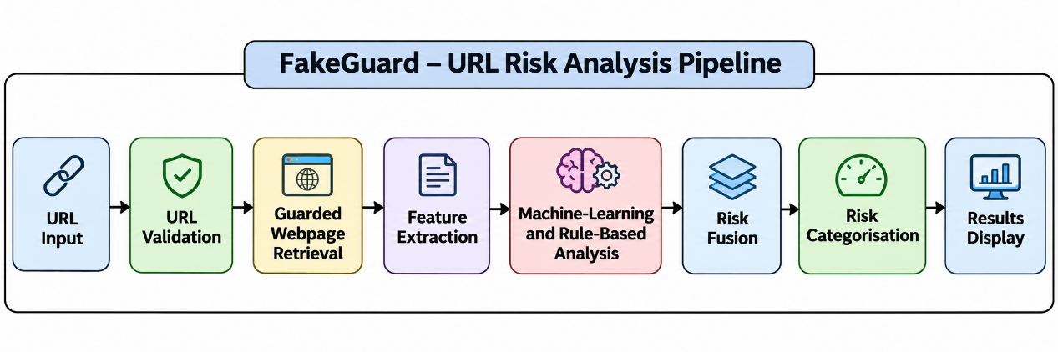
b. Video Demonstration
https://drive.google.com/file/d/17R7_-NC3FKG5JXw1Ii4XJGw-7d_hWX_8/view?usp=drive_link

Figure 1: FakeGuard Application Interface
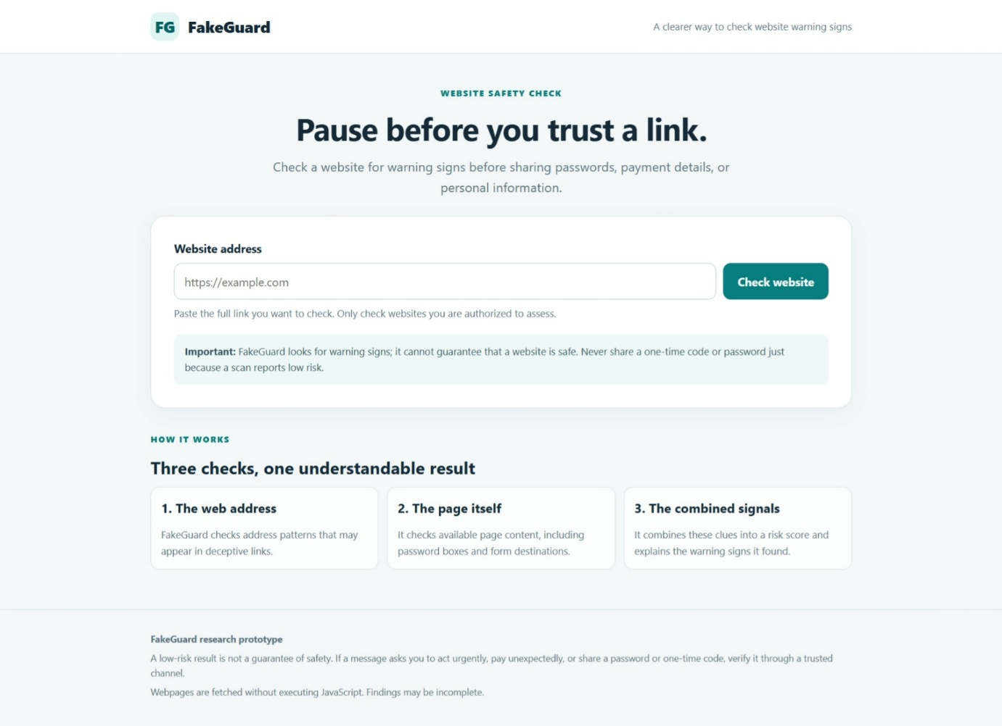
Figure 2: Website Analysis Results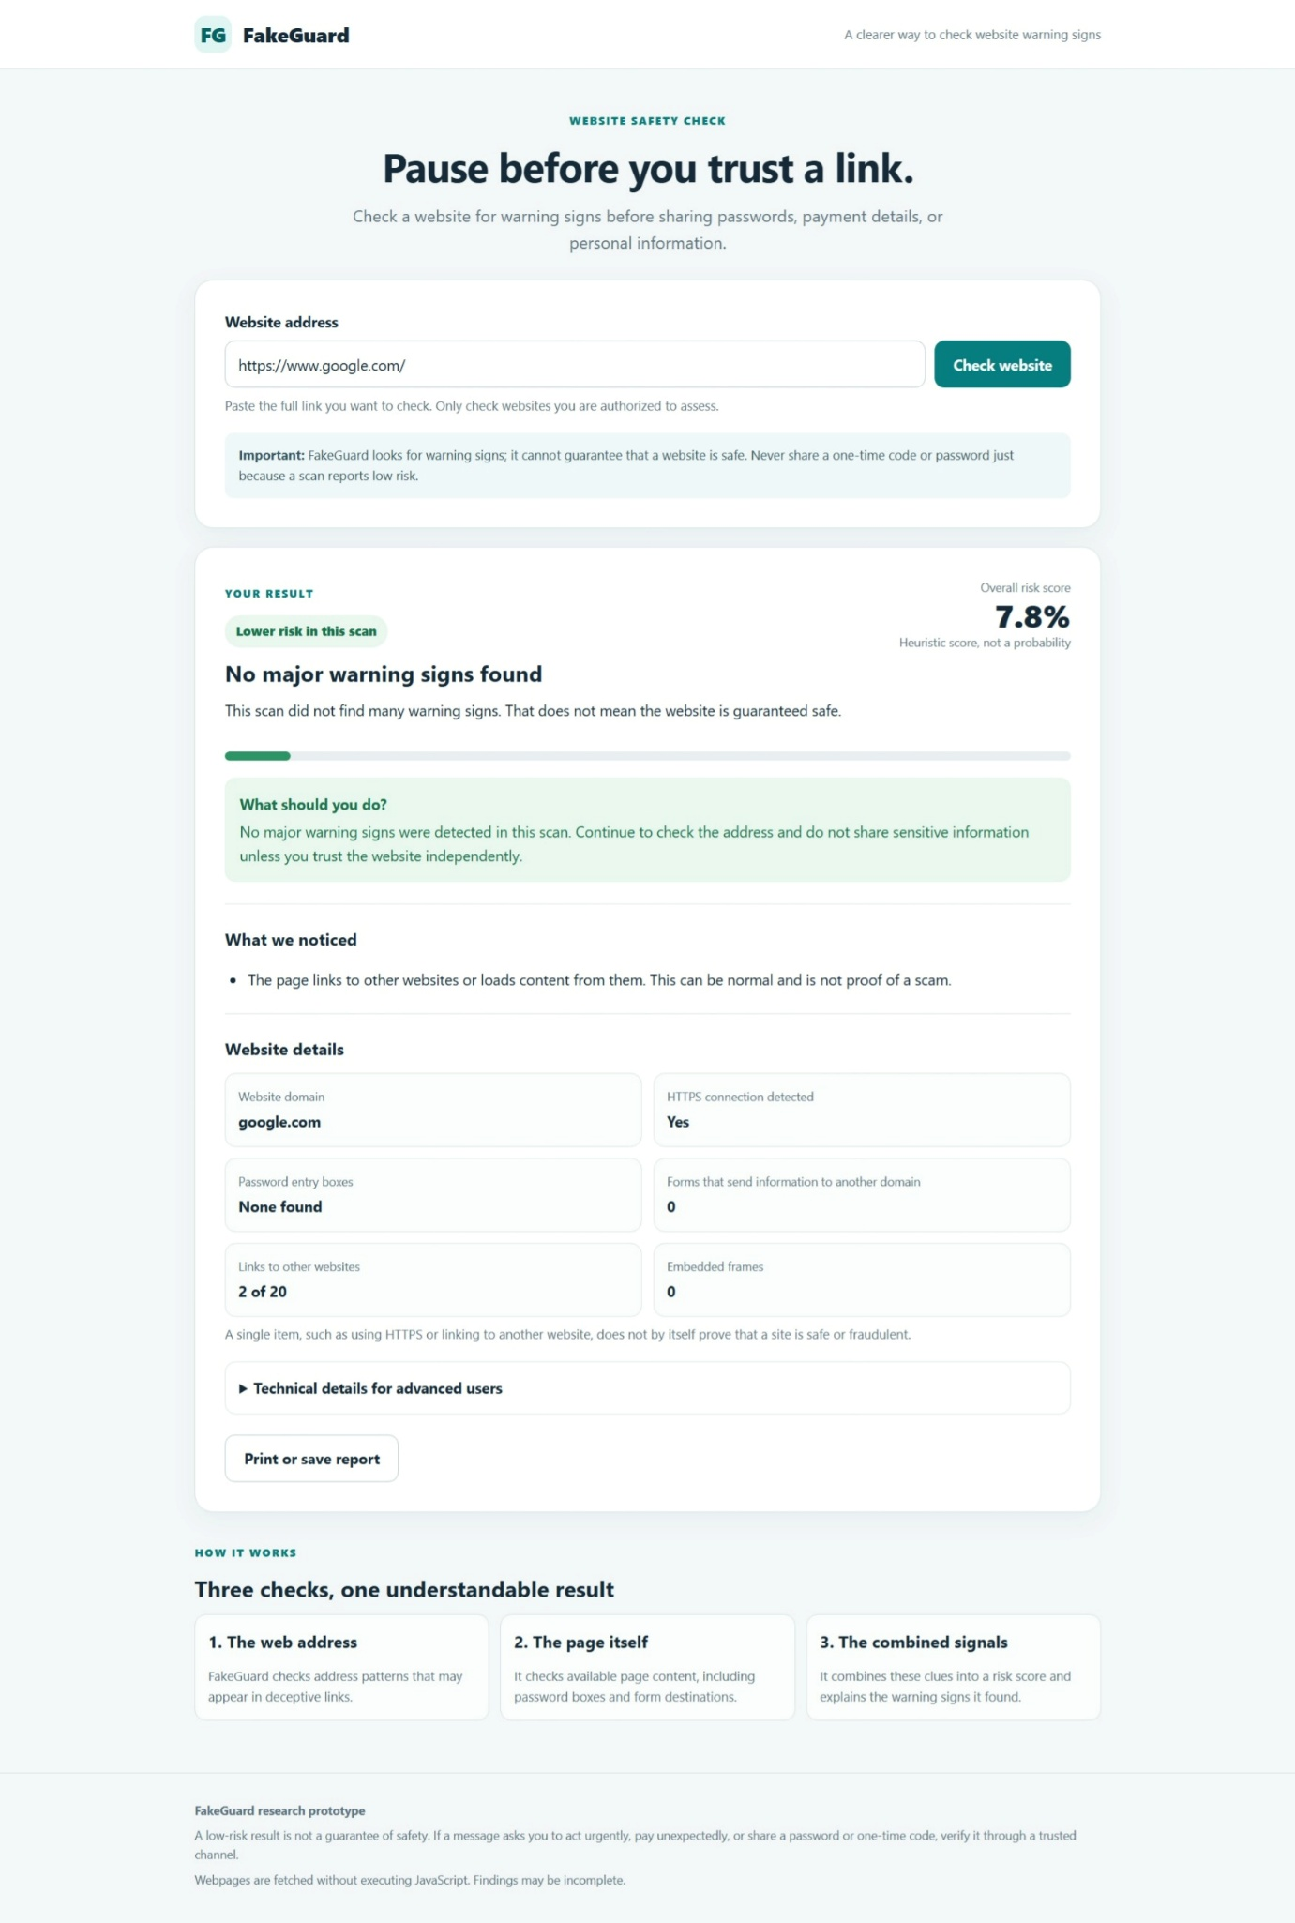

9. Comparison with Existing Technology
a. Present technology or methods used to address the problem
Existing approaches include URL blacklists and reputation services, URL-feature-based machine-learning classifiers, rule-based webpage analysis, webpage-content classification, and commercial browser, endpoint, email, and network-security products.
b. Limitations of existing technology
Depending on the method, limitations may include reliance on known malicious URLs, difficulty detecting newly created websites, incomplete analysis of webpage characteristics, limited explanation of risk decisions, and false positives caused by legitimate but unusual websites.
These limitations vary between technologies and do not apply equally to all existing products.
c. How the present invention overcomes these limitations
FakeGuard supplements machine-learning analysis with selected webpage and identity-related checks. The combined risk score can reflect webpage characteristics that may not be represented adequately by the URL model alone. The application displays the detected indicators and explains why it recommends further review.
The guarded-fetching component also introduces restrictions intended to reduce risks during webpage retrieval.
The effectiveness of these measures requires further evaluation and has not been established across all real-world websites.
d. Advantages of the invention
- Provides a web-based interface for phishing-risk assessment.
- Combines different types of URL and webpage indicators in one workflow.
- Explains the reasons for a warning instead of displaying only a score.
- Analyses accessible webpage HTML without executing JavaScript.
- Incorporates safeguards for retrieving user-supplied URLs.
- Supports testing, cybersecurity education, and research.
- Allows the results to be reviewed, printed, or saved through the available interface.
Quantified improvements in detection accuracy, cost, or investigation time have not yet been established.

10. Experimental Data — Complete Experimental Procedure
10.1. Experimental environment
FakeGuard was executed on Windows using Python in a project-specific virtual environment. The Flask application was started using python app.py and accessed through http://127.0.0.1:5000.
10.2. Syntax validation
The following command was executed:
python -m py_compile app.py feature_engine.py risk_engine.py
Observed result: The command completed without reporting syntax errors.
10.3. Automated testing
The project dependencies were installed in the virtual environment, including pytest. The automated test suite was executed using:
python -m pytest -q
Observed result: 38 tests passed in approximately 9.81 seconds.
The suite covered application integration, brand mismatch checks, brand-review thresholds, feature extraction, fetcher security, HTML link and tag mapping, model-fixture behaviour, risk-engine behaviour, and URL-related feature mappings.
This result establishes that the included test cases passed in the tested environment. It does not establish complete correctness for all URLs or phishing techniques.
10.4. Controlled fixture evaluation
The following command was executed:
python test_real_model_fixture.py
Two fixture cases were evaluated: an ordinary webpage and a suspicious login-page example.
Test case | Final risk score | Displayed result
Ordinary webpage fixture | 0.0% | Low risk — likely legitimate
Suspicious login-page fixture | 66.7% | Medium risk — review required
For the suspicious fixture, the application identified a password field, a form sending information to a different website, account/login-related terms, and concerns arising from the difference between the URL-model assessment and webpage signals.
These results are from controlled fixtures and do not represent general real-world detection accuracy.
10.5. Live webpage tests
The following outputs were observed during testing on 26 October 2026.
Test input | Observed result | Notes
https://www.google.com/ | 7.8% risk | Low-risk result
https://www.wikipedia.org/ | 11.6% risk | Low-risk result; minor inconsistency in warning wording observed
Reserved .example address | No successful risk score | Scan did not complete successfully
Live page accessed through a temporary trycloudflare.com hostname | 54.8% risk | Medium-risk result
The live demonstration result displayed the following indicators:
- URL model score: 42.8%.
- Page-behaviour score: 65.0%.
- Identity/deception signal: 75.0%.
- HTTPS detected: Yes.
- Password fields: 1.
- External form destinations: 0.
- External links: 14 of 15.
- Embedded frames: 1.
The system reported the presence of a password field, external links, an embedded frame, and account/password-related terms among the reasons for caution.
The domain alone does not establish that a website is malicious. This result demonstrates that the application retrieved and analysed the accessible page and generated a risk assessment from its detected indicators.
10.6 Offline Runtime Model Evaluation — UCI Phishing Websites Dataset
The runtime machine-learning model was evaluated using the UCI Phishing Websites dataset (ID 327). The evaluation used 22 URL-oriented features and a stratified 80:20 training/testing split with random state 42. The test set contained 2,211 records.
The reported model-level evaluation results were:
- Accuracy: 94.6178%
- Precision: 94.0635%
- Recall: 93.7755%
- F1-score: 93.9193%
- ROC-AUC: 98.8623%
- Average Precision: 98.7224%
- False Positive Rate: 4.7116%
The confusion matrix recorded 1,173 true negatives, 58 false positives, 61 false negatives, and 919 true positives.
These measurements represent offline model evaluation on the specified dataset split. They do not represent the end-to-end detection accuracy of the live FakeGuard application.

10.7 Separate Benchmark Evaluation — PhiUSIIL Dataset
A separate benchmark experiment was conducted using the PhiUSIIL phishing URL dataset (UCI ID 967), with 47 selected URL and webpage-related features.
The experiment used 189,074 training records. The original test set contained 46,721 records. After excluding 8,418 repeated-pattern test records, the retained test set contained 38,303 records.
The evaluation report indicated no domain overlap and no exact selected-feature-vector overlap between the retained test data and training data.
The reported evaluation results were:
- Accuracy: 99.9922%
- Precision: 100.0000%
- Recall: 99.9737%
- F1-score: 99.9868%
- ROC-AUC: 99.9999%
- Average Precision: 99.9998%
- False Positive Rate: 0.0000%
The confusion matrix recorded 26,912 true negatives, zero false positives, three false negatives, and 11,388 true positives.
These results apply only to this separate offline benchmark experiment and its specified dataset and feature-selection procedure. They must not be interpreted as the live FakeGuard application's real-world phishing detection accuracy. Further independent evaluation is required to investigate possible dataset and collection-related effects.
10.8 Feature Ablation Experiment
An additional offline ablation experiment was conducted to examine the contribution of the sslfinal_state feature in the UCI Phishing Websites dataset (ID 327) runtime model.
The current 22-feature model achieved 94.62% accuracy and 93.92% F1-score on the specified test split. A separate candidate model trained without the SSL feature achieved 91.45% accuracy and 90.36% F1-score.
The candidate without the SSL feature was not saved or deployed. A separate feature-encoding stress test changed 48 of 2,211 predictions and reduced recall to 88.88% when neutral SSL values were changed to positive values.
These experiments were conducted as model-level diagnostics. They indicate sensitivity to the selected feature representation and do not establish general live detection performance.
10.9 Exploratory External URL Validation
An exploratory external URL pilot was performed using a 20-URL sample consisting of verified or online PhishTank entries and popular-domain candidates selected from Tranco.
Thirteen scans completed successfully, while seven scans failed.
Among the successfully scanned PhishTank entries, five out of seven reached the 45/100 manual-review threshold after applying the provisional brand-domain mismatch review floor. Six Tranco candidates were successfully scanned, and none reached the review threshold.
This was a small exploratory pilot. The PhishTank result is not the standalone machine-learning detection rate because the brand-domain review floor contributed to the outcome. Tranco popularity candidates were not independently confirmed legitimate ground truth and therefore cannot be used to calculate a false-positive rate. Failed scans were excluded from the successful-scan denominators.
10.10 Overall Interpretation
The experimental work includes automated software testing, controlled fixture evaluation, offline machine-learning benchmarking, feature ablation, and a small exploratory external URL pilot.
The results demonstrate that the software prototype operates and that its machine-learning and rule-based components have been evaluated under selected controlled conditions.
The results do not establish comprehensive real-world detection accuracy or superiority over existing commercial phishing-detection systems. The displayed application score is a heuristic rather than a calibrated probability.
Further independent labelled-dataset evaluation, reproducible external validation, and comparative experimentation are required.

11. Uses, Applications and Benefits
a. Application areas
- Cybersecurity education and research.
- Phishing-risk demonstrations and security awareness.
- Preliminary assessment of suspicious URLs and webpages.
- Security investigation and triage workflows.
- Research on explainable and hybrid phishing detection.
- Potential integration into larger web-security tools after further validation.
b. Does it improve an existing technology? If yes, how?
FakeGuard seeks to broaden phishing-risk assessment by combining machine-learning output with selected webpage and identity-related indicators. It also presents explanatory information about the detected warning signs and incorporates guarded retrieval of webpage HTML.
Any measurable improvement in detection accuracy, robustness, or operational performance must be established by comparative experiments.
c. Beneficiaries / End Users
Potential beneficiaries include students, cybersecurity researchers, security educators, security analysts, small organisations, enterprise security teams, and developers of web-security applications.
d. Benefits
- Provides a single interface for URL and webpage risk assessment.
- Helps identify webpage characteristics that may warrant further investigation.
- Reduces reliance on an unexplained model score alone.
- Supports reproducible demonstrations and testing.
- May assist in prioritising manual security review when used appropriately.
No quantified financial savings or reduction in phishing incidents has yet been established.
12. Disadvantages and Limitations
a. Challenges in cost, scale-up or large-scale manufacturing
FakeGuard is software-based and does not require physical manufacturing. Large-scale deployment would require consideration of hosting, concurrency, network-fetching capacity, logging, monitoring, dependency maintenance, model updates, and operational support.
Fetching arbitrary URLs introduces infrastructure and abuse risks that require continued security review.
b. Regulatory, safety or approval requirements
Before commercial deployment, applicable data-protection and cybersecurity requirements, website-access terms, data-retention practices, and hosting-security requirements should be reviewed.
Institutional intellectual-property procedures and any relevant agreements should also be followed. The current prototype should not be presented as a certified security product.
c. Aspects remaining untested or requiring further validation
- Testing on larger, independently labelled datasets of legitimate and phishing websites.
- Measuring precision, recall, F1 score, false-positive rate, and false-negative rate under documented test conditions.
- Comparing the results with relevant baseline detection methods.
- Evaluating previously unseen brands and domains.
- Testing dynamic webpages that depend on JavaScript.
- Evaluating different redirects, network conditions, and unavailable webpages.
- Conducting a security review of the webpage-fetching component, including possible DNS-rebinding and related network risks.
- Improving the completeness of the supported brand-domain list.
- Testing the sensitivity of scoring thresholds and conditional adjustments.
- Conducting independent usability and security evaluations.
13. Publications and Public Disclosures
No published manuscript, journal article, or conference paper relating specifically to this FakeGuard project has been identified in the information available for this disclosure. This must be confirmed before submission.
A live webpage scan using a temporary HTTPS tunnel associated with a trycloudflare.com hostname was performed during the project demonstration on 26 October 2026. The application was also operated locally during development and testing.
The circumstances of the live demonstration should be recorded accurately, including whether the URL, screenshots, source code, or technical details were shared outside the project team or made publicly accessible.
Whether any demonstration constitutes a legally relevant public disclosure depends on the specific circumstances. The Technology Transfer Cell should be informed of the demonstration before deciding on filing and publication plans.
No future publication or external presentation date has been confirmed in this disclosure. If patent protection is being considered, the Technology Transfer Cell should be consulted before publishing or presenting further technical details.
14. Prior Art Search Details
Search status: Preliminary search of public patent and scholarly records on 27 October 2026. This is not an exhaustive patentability search or a legal opinion on novelty, inventive step, or freedom to operate.
a. Patent database
A preliminary search of Google Patents identified the following relevant documents:
1. Detecting Phishing Websites via a Machine Learning-Based System Using URL Feature Hashes, HTML Encodings and Embedded Images of Content Pages
Publication number: US12231464B2
Link: https://patents.google.com/patent/US12231464B2/en
This document describes phishing classification using URL features, HTML encodings, and webpage image representations.
2. Phishing Detection System and Method of Use
Publication number: US20220070216A1
Link: https://patents.google.com/patent/US20220070216A1/en
This document describes retrieving webpages and analysing webpage characteristics, including forms, content, and machine-learning-based signals, for phishing detection.
3. Phishing Detection Based on Modeling of Web Page Content
Publication number: US12021894B2
Link: https://patents.google.com/patent/US12021894B2
This document describes URL-related scoring and webpage-content analysis for generating phishing-related scores.
These records show that general concepts involving URL and webpage analysis are already present in the public patent literature. A detailed comparison of the claims and technical implementations is required to evaluate whether the specific features of FakeGuard are distinguishable.
b. Non-patent database
A preliminary search of IEEE Xplore identified the following relevant publication:
1. Feature Engineering for Phishing Website Detection Using Machine Learning: A Systematic Review
Published in IEEE Access, 7 November 2025.
Link: https://ieeexplore.ieee.org/abstract/document/11231397
The review discusses URL, HTML/content, domain, behavioural, and combined feature approaches to phishing detection.
2. Detection of Phishing URLs Using Machine Learning and Multi-Level Feature Extraction
Published in the 2026 IEEE Madhya Pradesh Section Conference proceedings.
Link: https://ieeexplore.ieee.org/abstract/document/11508303
The paper describes a machine-learning approach combining domain-related, URL-related, and webpage-related feature groups.
c. Specialized patent analytics tools
No search of The Lens, Derwent Innovation, or Orbit Intelligence has been documented for this disclosure. These searches may be conducted as part of a formal novelty review.
Further searches should be conducted through Espacenet, WIPO PATENTSCOPE, USPTO patent databases, Google Scholar, IEEE Xplore, and ScienceDirect using terms relating to hybrid phishing detection, weighted risk fusion, conditional risk adjustments, brand-domain mismatch assessment, explainable risk scoring, and guarded webpage retrieval.
The Technology Transfer Cell or a patent professional should perform a detailed prior-art assessment before any representation is made that FakeGuard is novel or patentable.
Manuscript: No manuscript is attached to this disclosure. Attach the relevant project documentation, source-code description, architecture diagram, screenshots, and experimental records where appropriate.
15. Identification of Inventor(s)
Name of inventors: Ganesh Ghantasala (AP26122050003)
Bhargav Tiruveedhula (AP26122050006
Institution: SRM University-AP
Programme: M.Tech. Cyber Security
Contribution: Development and testing of the FakeGuard software prototype, including implementation and evaluation of the URL analysis, webpage feature extraction, and risk-assessment workflow, subject to confirmation of the actual inventive contribution.

16. Signature of Inventor(s) and Date
Name: Ganesh Ghantasala
Signature: ______________________________
Date: 27 October 2026

ANNEXURE B-1: COMMERCIALISATION

1. Stages of Development — Technology Readiness Levels
Selected stage:
[ ] TRL 1 — Basic principles observed
[ ] TRL 2 — Technology concept formulated
[ ] TRL 3 — Experimental proof of concept
[✓] TRL 4 — Technology validated in laboratory
[ ] TRL 5 — Technology validated in a relevant environment
[ ] TRL 6 — Technology demonstrated in a relevant environment
[ ] TRL 7 — System prototype demonstrated in an operational environment
[ ] TRL 8 — System complete and qualified
[ ] TRL 9 — Actual system proven in an operational environment

Justification / Supporting Evidence
FakeGuard has been implemented as a working Python/Flask software prototype. The principal source files passed a Python syntax check, and the automated test suite reported 38 passing tests. Controlled fixture testing produced different risk assessments for an ordinary webpage and a suspicious login-page fixture. The application was also used to analyse accessible live webpages, including a page accessed through a temporary HTTPS tunnel.
These results support laboratory validation of the software prototype. However, extensive independent testing, production hardening, broad operational validation, and commercial qualification have not yet been established. TRL 4 is therefore the conservative classification based on the evidence currently available.

2. Patent Technology Classification
[ ] Advanced Materials & Manufacturing
[ ] Aerospace & Defense Technologies
[ ] Applied Mechanics & Mechanical Engineering
[✓] Artificial Intelligence (AI) & Machine Learning
[ ] Assistive, Test Equipment and Design Manufacturing
[ ] Automobile & Transportation
[ ] Biotechnology & Genetic Engineering
[ ] Blockchain
[ ] Chemistry & Chemical Analysis
[ ] Civil Infrastructures & Structural Engineering
[ ] Computer Aided Design & CAD Analysis
[✓] Computer Hardware, Software & Algorithms
[✓] Data Science & Database Systems
[ ] Drugs & Pharmaceutical Engineering
[ ] Electronics & Circuits
[ ] Energy, Energy Storage & Renewable Energy
[ ] Environmental Engineering
[ ] Food & Nutrition
[ ] Green Technology
[ ] Hyperloop
[✓] Information & Communication Technologies (ICT)
[ ] Internet of Things (IoT)
[ ] Medical & Surgical Devices
[ ] Micro & Nano Technologies
[ ] Non-Destructive Testing Methods & Equipment (NDT/NDE)
[ ] Photonics
[ ] Quantum Technology
[ ] Robotics & Automation
[ ] 5G & Next Generation Networks
[ ] Virtual Reality (VR) & Augmented Reality (AR)
[ ] Other Technologies

3. Licensing Potential
[ ] High
[✓] Medium
[ ] Low
Remarks / Justification
The project may have licensing or technology-transfer potential in cybersecurity software, security awareness tools, URL-analysis services, and security investigation workflows. The software-based architecture does not require specialised physical manufacturing.
The potential remains provisional because broader independent validation, formal prior-art assessment, security review, usability testing, and comparison with existing products are required. This assessment is not a prediction of licensing revenue or commercial success.

4. Other Information / Leads for Commercialisation
Potential commercialisation opportunities include:
- Cybersecurity service providers and managed security service providers that may evaluate URL and webpage risk assessment for investigation or triage.
- Enterprise IT and security teams that may assess the software as a supplementary tool for reviewing suspicious URLs, subject to security requirements.
- Browser, web-security, and email-security developers that may evaluate integration of selected analysis or risk-explanation components.
- Educational institutions and cybersecurity training providers that may use the prototype for teaching and controlled demonstrations.
- Cybersecurity research organisations that may further evaluate hybrid risk scoring, explainability, and guarded webpage retrieval.
No confirmed licensee, investor, commercial partner, or pilot customer has been identified at the time of preparing this disclosure.

